3.Numerical Integration and Differentiation

3a.Numerical integration
Numerical integration, also known as numerical quadrature, is a set of techniques used to approximate the value of a definite integral when a closed-form solution is difficult or impossible to obtain. It involves dividing the area under the curve into smaller, simpler shapes (like rectangles or trapezoids) and summing their areas to estimate the total area, which represents the integral.
Why use numerical integration?

- Intractable Integrals:
Many functions don't have elementary antiderivatives, making traditional integration methods impossible.
- Empirical Data:
Numerical integration can be applied to data points that are not defined by a function, allowing for the analysis of experimental or observed data.
- Computational Efficiency:
For complex functions or when high accuracy is not required, numerical methods can be faster and more efficient than finding a closed-form solution.
Common Numerical Integration Methods:
- Trapezoidal Rule:
Approximates the area under the curve using trapezoids.
- Simpson's Rule:
Uses parabolic segments to approximate the curve, typically providing more accurate results than the trapezoidal rule.
- Midpoint Rule:
Uses rectangles where the height is determined by the function's value at the midpoint of each subinterval.
- Romberg Integration:
A more advanced method that refines the trapezoidal rule by extrapolating to improve accuracy.

Numerical integration has roots in the geometrical problem of finding a square with the same area as a given plane figure (quadrature or squaring), as in the quadrature of the circle. The term is also sometimes used to describe the numerical solution of differential equations.
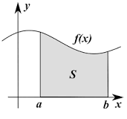

Numerical integration using the Trapezoidal and Simpson's rules in Python:
Trapezoidal Rule
The trapezoidal rule approximates the definite integral of a function by dividing the area under the curve into trapezoids and summing their areas. It's a basic method that approximates the function with straight lines between points.

def trapezoidal_rule(func, a, b, n):
h = (b - a) / n
s = func(a) + func(b)
for i in range(1, n):
s += 2 * func(a + i * h)
return (h / 2) * s
func: The function to be integrated,
a: Lower limit of integration,
b: Upper limit of integration, and
n: Number of trapezoids (subintervals).
Import math
# Example function
def f(x):
return math.sin(x)
# Integration limits
a = 0
b = math.pi
n = 100# Number of subintervals
# Apply trapezoidal rule
trapezoidal_result = trapezoidal_rule(f, a, b, n)
print(f"Trapezoidal Rule: {trapezoidal_result}")

Simpson's Rule
Simpson's rule approximates the definite integral by using quadratic polynomials to fit the function on subintervals, providing a more accurate approximation compared to the trapezoidal rule. Simpson's 1/3 rule is commonly used.

def simpsons_rule(func, a, b, n):
if n % 2 != 0:
raiseValueError("n must be an even number for Simpson's rule.")
h = (b - a) / n
s = func(a) + func(b)
for i in range(1, n, 2):
s += 4 * func(a + i * h)
for i in range(2, n - 1, 2):
s += 2 * func(a + i * h)
return (h / 3) * s

- func: The function to be integrated.
- a: Lower limit of integration.
- b: Upper limit of integration.
- n: Number of subintervals (must be even for Simpson's 1/3 rule).
Import math
# Example function
def f(x):

return math.sin(x)
# Integration limits
a = 0
b = math.pi
n = 100# Number of subintervals
# Apply trapezoidal rule
trapezoidal_result = trapezoidal_rule(f, a, b, n)
print(f"Trapezoidal Rule: {trapezoidal_result}")
# Apply Simpson's rule
simpson_result = simpsons_rule(f, a, b, n)
print(f"Simpson's Rule: {simpson_result}")

Key Differences
- Accuracy:
Simpson's rule is generally more accurate than the trapezoidal rule for the same number of subintervals, as it uses quadratic approximations.
- Subintervals:
The trapezoidal rule can use any number of subintervals, while Simpson's 1/3 rule requires an even number of subintervals.
- Complexity:
Simpson's rule involves slightly more complex calculations than the trapezoidal rule.
- Error:
The error in the trapezoidal rule decreases at a rate of 1/n^2, while in Simpson's rule, it decreases at a rate of 1/n^4, where n is the number of subintervals.

Additional Notes
- For higher accuracy, increase the number of subintervals (n).
- Simpson's 3/8 rule is another variant of Simpson's rule that uses cubic approximations and requires the number of subintervals to be a multiple of 3.
- Libraries like SciPy provide optimized integration functions that can be used for numerical integration tasks.

implement Simpson's 1/3 rule using Python:
Simpson's 1/3 rule is a numerical method for approximating the definite integral of a function. It works by dividing the interval of integration into an even number of subintervals and approximating the function on each pair of subintervals by a quadratic polynomial.
Formula
The formula for Simpson's 1/3 rule is:
Code
∫[a, b] f(x) dx ≈ (h/3) * [f(x₀) + 4f(x₁) + 2f(x₂) + 4f(x₃) + ... + 2f(xₙ₋₂) + 4f(xₙ₋₁) + f(xₙ)]
where:
- a is the lower limit of integration
- b is the upper limit of integration
- n is the number of subintervals (must be even)
- h = (b - a) / n is the width of each subinterval
- xᵢ = a + i * h are the points at which the function is evaluated
Python Implementation
Python
import numpy as np
def simpson_1_3(f, a, b, n):
"""
Approximates the definite integral of f(x) from a to b using Simpson's 1/3 rule.

Args:
f: The function to be integrated.
a: The lower limit of integration.
b: The upper limit of integration.
n: The number of subintervals (must be even).

Returns:
The approximate value of the definite integral.
"""
if n % 2 != 0:
raise ValueError("The number of subintervals (n) must be even for Simpson's 1/3 rule.")
h = (b - a) / n
x = np.linspace(a, b, n + 1)
y = f(x)
integral = h/3 * (y[0] + 2*sum(y[2:-1:2]) + 4*sum(y[1:-1:2]) + y[-1])
…………………………………….
return integral
Example Usage
Python
# Example function to integrate
def f(x):
return x**2
# Integration limits
a = 0
b = 1
# Number of subintervals
n = 100
# Calculate the integral using Simpson's 1/3 rule
result = simpson_1_3(f, a, b, n)
# Print the result
print(f"Approximate integral: {result}")
Important Notes
- The number of subintervals (n) must be an even number for Simpson's 1/3 rule.
- The accuracy of the approximation increases as the number of subintervals increases.
- Simpson's 1/3 rule is generally more accurate than the trapezoidal rule for the same number of subintervals.

The Simpson's 3/8 rule is a numerical method for approximating the definite integral of a function. It is a more accurate method than the trapezoidal rule, and it is based on approximating the function with a cubic polynomial.
Here's a breakdown of the Simpson's 3/8 rule in Python:
1. Formula
The Simpson's 3/8 rule approximates the integral of a function f(x) over an interval \[a, b] using the following formula:
Code
∫[a, b] f(x) dx ≈ (3h/8) * [f(x₀) + 3f(x₁) + 3f(x₂) + 2f(x₃) + 3f(x₄) + 3f(x₅) + 2f(x₆) + ... + 3f(xₙ₋₂) + 3f(xₙ₋₁) + f(xₙ)]
Where:
- h = (b - a) / n is the width of each subinterval.
- n is the number of subintervals, which must be a multiple of 3.
- xᵢ = a + i * h are the points at which the function is evaluated.
- The coefficients follow a pattern: 1, 3, 3, 2, 3, 3, 2, ... 3, 3, 1.
2. Python Implementation
Python
def simpson_3_8_rule(f, a, b, n):
"""
Approximates the definite integral of f(x) from a to b using Simpson's 3/8 rule.

Args:
f: The function to integrate.
a: The lower limit of integration.
b: The upper limit of integration.
n: The number of subintervals (must be a multiple of 3).

Returns:
The approximate value of the integral.
"""
if n % 3 != 0:
raise ValueError("The number of subintervals (n) must be a multiple of 3 for Simpson's 3/8 rule.")
h = (b - a) / n
x = [a + i * h foriin range(n + 1)]
y = [f(xi) forxiin x]
sum_val = y[0] + y[n]
for i in range(1, n):
if i % 3 == 0:
sum_val += 2 * y[i]
else:
sum_val += 3 * y[i]
return (3 * h / 8) * sum_val
# Example usage:
def f(x):
return x**2
a = 0
b = 1
n = 6# Must be a multiple of 3
integral = simpson_3_8_rule(f, a, b, n)
print(f"The approximate integral is: {integral}")
Explanation:
- The code first checks if n is a multiple of 3.
- It calculates the width of each subinterval h.
- It creates a list x with the points at which the function is evaluated.
- It creates a list y with the function values at each point.
- It then iterates through the y list to calculate the weighted sum according to the rule.
- Finally, it returns the approximate value of the integral.
Key Points:
- Accuracy:
Simpson's 3/8 rule is generally more accurate than Simpson's 1/3 rule, but requires one more function evaluation.
- Subintervals:
The number of subintervals n must be a multiple of 3 for this rule to be applicable.
- Error:
The error in Simpson's 3/8 rule is proportional to the fourth derivative of the function, making it quite accurate for smooth functions.
This comprehensive explanation should help you understand and implement Simpson's 3/8 rule in Python effectively.

3b.Solving Differential Equations
Numerical differentiation is a method used to approximate the value of a derivative of a function at a given point when the function's analytical expression is not available or is difficult to differentiate directly. It utilizes function values at specific points to estimate the rate of change, often employing techniques like forward, backward, or central differences.
Explanation:
- Purpose:
Numerical differentiation is essential when dealing with functions defined by data points, complex expressions, or functions that are computationally expensive to differentiate analytically.
- Methods:
Several techniques exist, including:
  - Forward Difference: Approximates the derivative using the function's value at the current point and a point slightly ahead. Formula: f'(x) ≈ (f(x + h) - f(x)) / h, where h is a small step size.
  - Backward Difference: Uses the function's value at the current point and a point slightly behind. Formula: f'(x) ≈ (f(x) - f(x - h)) / h.
  - Central Difference: Averages the forward and backward difference approximations, generally providing a more accurate estimate. Formula: f'(x) ≈ (f(x + h) - f(x - h)) / (2h).

Error Analysis:
Numerical differentiation introduces error due to the approximation of the derivative. The step size (h) plays a crucial role, with smaller step sizes generally leading to more accurate results, but can also introduce issues due to limited precision on computers. Higher-order methods and techniques like Richardson extrapolation can be used to mitigate these errors.

Applications:

Numerical differentiation is widely used in various fields, including:

  - Solving differential equations
  - Analyzing data from experiments or simulations
  - Optimization algorithms
  - Financial modeling

Implement the Euler and Runge-Kutta methods for solving differential equations in Python:
Euler's Method
Euler's method is a first-order numerical procedure for approximating the solution of an ordinary differential equation (ODE) with a given initial value. It uses the derivative at the beginning of the interval to extrapolate the solution to the end of the interval.
Python
def euler_method(f, y0, t0, tf, h):
"""
Approximates the solution of an ODE using Euler's method.

Args:
f: The derivative function dy/dt.
y0: The initial value y(t0).
t0: The initial time.
tf: The final time.
h: The step size.

Returns:
A tuple containing lists of time points and corresponding y values.
"""
t = t0
y = y0
t_values = [t]
y_values = [y]
while t <tf:
y = y + h * f(t, y)
t = t + h
t_values.append(t)
y_values.append(y)
returnt_values, y_values

Runge-Kutta Method (4th Order)

The Runge-Kutta method is a family of higher-order numerical procedures for approximating solutions of ODEs. The fourth-order Runge-Kutta method is a popular choice due to its balance between accuracy and computational cost. It uses a weighted average of slopes at different points within the interval to extrapolate the solution.
def runge_kutta_4th_order(f, y0, t0, tf, h):
"""
Approximates the solution of an ODE using the 4th order Runge-Kutta method.

Args:
f: The derivative function dy/dt.
y0: The initial value y(t0).
t0: The initial time.
tf: The final time.
h: The step size.

Returns:
A tuple containing lists of time points and corresponding y values.
"""
t = t0
y = y0
t_values = [t]
y_values = [y]
while t <tf:
k1 = h * f(t, y)
k2 = h * f(t + h/2, y + k1/2)
k3 = h * f(t + h/2, y + k2/2)
k4 = h * f(t + h, y + k3)
y = y + (k1 + 2*k2 + 2*k3 + k4) / 6
t = t + h
t_values.append(t)
y_values.append(y)
return t_values, y_values
Example Usage
Let's solve the differential equation dy/dt = t - y with initial condition y(0) = 1 using both methods:
def f(t, y):
return t - y
y0 = 1
t0 = 0
tf = 5
h = 0.1
t_euler, y_euler = euler_method(f, y0, t0, tf, h)
t_rk4, y_rk4 = runge_kutta_4th_order(f, y0, t0, tf, h)
Important Notes
- Step Size (h):
Smaller step sizes generally lead to more accurate results but require more computational time.
- Error:
Euler's method is a first-order method, so its error is proportional to the step size. The fourth-order Runge-Kutta method is more accurate, with an error proportional to the fourth power of the step size.
- Stability:
For some ODEs, explicit methods like Euler's method can become unstable if the step size is too large.
- Choice of Method:
The choice between Euler's method and Runge-Kutta depends on the required accuracy and computational resources. Euler's method is simpler but less accurate, while Runge-Kutta is more accurate but computationally more expensive

3c. .Newtons FW BW Lagrange interpolation

Differentiation Via Interpolation In this section we demonstrate how to generate differentiation formulas by differentiating an interpolant. The idea is straightforward: the first stage is to construct an interpolating polynomial from the data. An approximation of the derivative at any point can be then obtained by a direct differentiation of the interpolate

Newton Forward And Backward Interpolation

Interpolation is the technique of estimating the value of a function for any intermediate value of the independent variable, while the process of computing the value of the function outside the given range is called extrapolation.
Forward Differences: The differences y1 – y0, y2 – y1, y3 – y2, ......,yn – yn–1 when denoted by dy0, dy1, dy2, ......, dyn–1 are respectively, called the first forward differences. Thus, the first forward differences are :
ΔYr=Yr+1−Yr ​
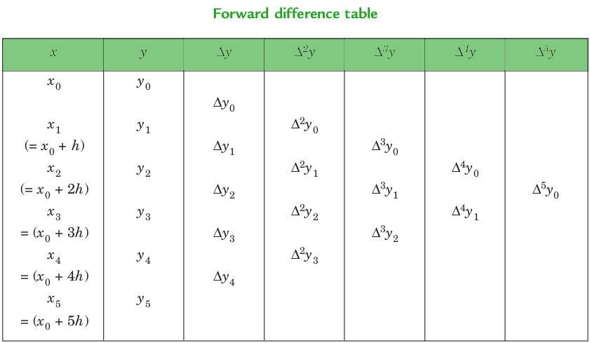
NEWTON’S GREGORY FORWARD INTERPOLATION FORMULA :
f(a+hu)=f(a)+uΔf(a)+u(u−1)2!Δ2f(a)+...+u(u−1)(u−2)...(u−n+1)n!Δnf(a) f(a+hu)=f(a)+uΔf(a)+2!u(u−1)​Δ2f(a)+...+n!u(u−1)(u−2)...(u−n+1)​Δnf(a)
This formula is particularly useful for interpolating the values of f(x) near the beginning of the set of values given. h is called the interval of difference and u = ( x - a ) / h, Here a is the first term.
Example :
Input : Value of Sin 52
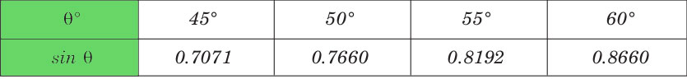
Output :
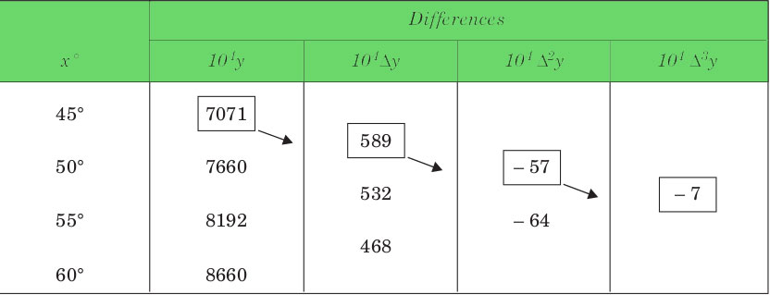
Value at Sin 52 is 0.788003
Below is the implementation of the Newton forward interpolation method.
# Python3 Program to interpolate using
# newton forward interpolation
​
Import numpy as np

def newton_forward_interpolation(x, y, value):
"""
Interpolates a value using Newton's forward interpolation method.

Args:
x: A list or numpy array of x-coordinates.
y: A list or numpy array of y-coordinates corresponding to x.
value: The x-value at which to interpolate.

Returns:
The interpolated y-value at the given x-value, or None if the input is invalid.
"""
n = len(x)
if n != len(y) or n < 2:
return None

h = x[1] - x[0]
if not np.all(np.diff(x) == h):
return None

# Calculate forward differences
forward_diff = np.zeros((n, n))
forward_diff[:, 0] = y
for i in range(1, n):
for j in range(n - i):
forward_diff[j, i] = forward_diff[j + 1, i - 1] - forward_diff[j, i - 1]

# Interpolation calculation
u = (value - x[0]) / h
interpolated_value = forward_diff[0, 0]
term = 1
for i in range(1, n):
term *= (u - (i - 1)) / i
interpolated_value += term * forward_diff[0, i]

return interpolated_value

if __name__ == "__main__":
x = [45, 50, 55, 60]
y = [0.7071, 0.7660, 0.8192, 0.8660]
value = 52

interpolated_y = newton_forward_interpolation(x, y, value)

if interpolated_y is not None:
print(f"The interpolated value at x = {value} is approximately {interpolated_y}")
else:
print("Invalid input data.")

Explanation:
- newton_forward_interpolation(x, y, value) function:
  - Takes the x-coordinates, y-coordinates, and the value to be interpolated as input.
  - Validates the input: Checks if the lengths of x and y are equal and greater than 1, and if the x-values are equally spaced.
  - Calculates the forward difference table.
  - Calculates the value of u based on the input value and the step size h.
  - Applies Newton's forward interpolation formula to calculate the interpolated value.
- Main execution block:
  - Defines sample data points x and y, and the value to interpolate.
  - Calls the newton_forward_interpolation function.
  - Prints the interpolated value or an error message if the input is invalid.
How to use:
- Save the code as a .py file.
- Run the file using python <filename>.py
- Change the sample data and the value to interpolate as needed.
This program provides a basic implementation of Newton's forward interpolation method, and it can be further extended to handle more complex scenarios.

Backward Differences: The differences y1 – y0, y2 – y1, ......,yn – yn–1 when denoted by dy1, dy2, ......, dyn, respectively, are called first backward difference. Thus, the first backward differences are :
∇Yr=Yr−Yr−1 ∇Yr​=Yr​−Yr−1​
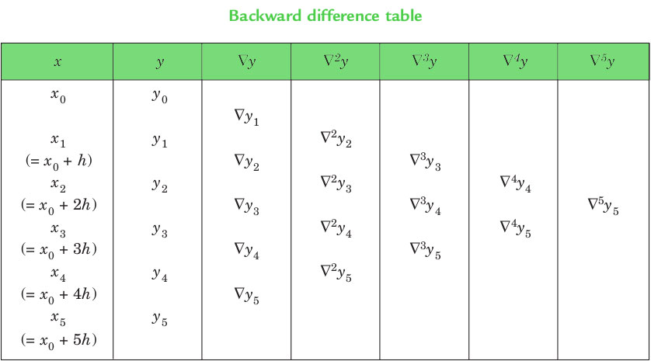
NEWTON’S GREGORY BACKWARD INTERPOLATION FORMULA :
f(a+nh+uh)=f(a+nh)+u∇f(a+nh)+u(u+1)2!∇2f(a+nh)+...+u(u+1)...(u+n−1‾)n!∇nf(a+nh) f(a+nh+uh)=f(a+nh)+u∇f(a+nh)+2!u(u+1)​∇2f(a+nh)+...+n!u(u+1)...(u+n−1​)​∇nf(a+nh)
This formula is useful when the value of f(x) is required near the end of the table. h is called the interval of difference and u = ( x - an ) / h, Here an is last term.
Example :
Input : Population in 1925
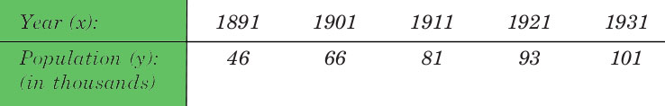
Output :
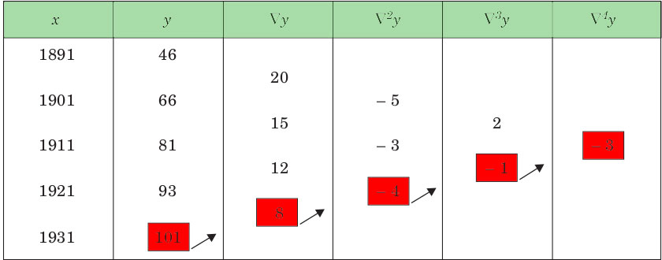
Value in 1925 is 96.8368
Below is the implementation of the Newton backward interpolation method.

# Python3 Program to interpolate using
# newton backward interpolation

# Calculation of u mentioned in formula
Def u_cal(u,n):
temp=u
for i in range(n):
temp=temp*(u+i)
return temp

# Calculating factorial of given n
Def fact(n):
f=1
for i in range(2,n+1):
f*=i
returnf

# Driver code

# number of values given
n=5
x=[1891,1901,1911,1921,1931]

# y is used for difference
# table and y[0] used for input
y=[[0.0,for_in range(n)]for__in range(n)]
y[0][0]=46
y[1][0]=66
y[2][0]=81
y[3][0]=93
y[4][0]=101

# Calculating the backward difference table
for i in range(1,n):
for j in range(n-1,i-1,-1):
y[j][i]=y[j][i-1]-y[j-1][i-1]

# Displaying the backward difference table
for i in range(n):
for j in range(i+1):
print(y[i][j],end="\t")
print()

# Value to interpolate at
value=1925

# Initializing u and sum
sum=y[n-1][0]
u=(value-x[n-1])/(x[1]-x[0])
for i in range(1,n):
sum=sum+(u_cal(u,i)*y[n-1][i])/fact(i)

print("\n Value at",value,"is",sum)

# This code is contributed by phasing17
Output:
46
66 20
81 15 -5
93 12 -3 2
101 8 -4 -1 -3

Value at 1925 is 96.8368
Time Complexity : O(N*N) ,N is the number of rows.
Space Complexity : O(N*N) ,for storing elements in difference table.

Lagrange Polynomial Interpolation
Lagrange's interpolation is an Nth degree polynomial approximation to f(x). This program implements Lagrange Interpolation Method for finding a polynomial in python programming language and it's necessary to enter X & Y. This program shows you the graph related to the polynomial and the data.
Rather than finding cubic polynomials between subsequent pairs of data points, Lagrange polynomial interpolation finds a single polynomial that goes through all the data points. This polynomial is referred to as a Lagrange polynomial, L(x), and as an interpolation function, it should have the property L(xi)=yi for every point in the data set. For computing Lagrange polynomials, it is useful to write them as a linear combination of Lagrange basis polynomials, Pi(x), where $Pi(x)=∏nj=1,j≠ix−xjxi−xj,
$and $L(x)=∑ni=1yiPi(x).
$ Here, ∏ means “the product of” or “multiply out.”
You will notice that by construction, Pi(x) has the property that Pi(xj)=1 when i=j and Pi(xj)=0 when i≠j. Since L(x) is a sum of these polynomials, you can observe that L(xi)=yi
for every point, exactly as desired.
EX1 : Find the Lagrange basis polynomials for the data set x = [0, 1, 2] and y = [1, 3, 2]. Plot each polynomial and verify the property that Pi(xj)=1when i=j and Pi(xj)=0 when i≠j
.
P1(x)P2(x)P3(x)===(x−x2)(x−x3)(x1−x2)(x1−x3)=(x−1)(x−2)(0−1)(0−2)=12(x2−3x+2),(x−x1)(x−x3)(x2−x1)(x2−x3)=(x−0)(x−2)(1−0)(1−2)=−x2+2x,(x−x1)(x−x2)(x3−x1)(x3−x2)=(x−0)(x−1)(2−0)(2−1)=12(x2−x).

import numpy as np
import numpy.polynomial.polynomial as poly
import matplotlib.pyplot as plt

plt.style.use('seaborn-poster')
x = [0, 1, 2]
y = [1, 3, 2]
P1_coeff = [1,-1.5,.5]
P2_coeff = [0, 2,-1]
P3_coeff = [0,-.5,.5]

# get the polynomial function
P1 = poly.Polynomial(P1_coeff)
P2 = poly.Polynomial(P2_coeff)
P3 = poly.Polynomial(P3_coeff)

x_new = np.arange(-1.0, 3.1, 0.1)

fig = plt.figure(figsize = (10,8))
plt.plot(x_new, P1(x_new), 'b', label = 'P1')
plt.plot(x_new, P2(x_new), 'r', label = 'P2')
plt.plot(x_new, P3(x_new), 'g', label = 'P3')

plt.plot(x, np.ones(len(x)), 'ko', x, np.zeros(len(x)), 'ko')
plt.title('Lagrange Basis Polynomials')
plt.xlabel('x')
plt.ylabel('y')
plt.grid()
plt.legend()
plt.show()

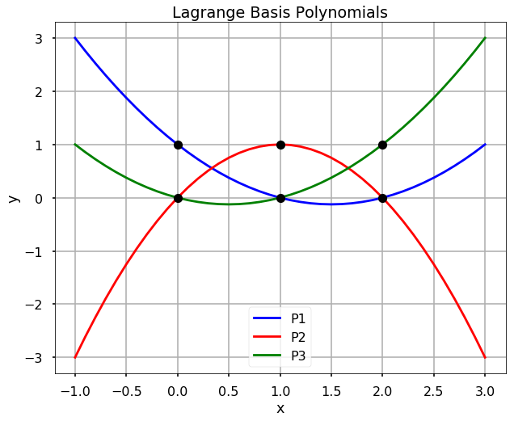
EX2 : For the previous example, compute and plot the Lagrange polynomial and verify that it goes through each of the data points.
L = P1 + 3*P2 + 2*P3

fig = plt.figure(figsize = (10,8))
plt.plot(x_new, L(x_new), 'b', x, y, 'ro')
plt.title('Lagrange Polynomial')
plt.grid()
plt.xlabel('x')
plt.ylabel('y')
plt.show()

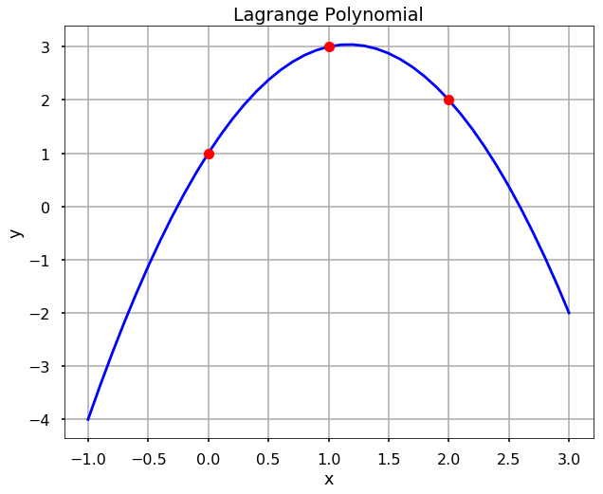
Note : Lagrange interpolation polynomials are defined outside the area of interpolation, that is outside of the interval [x1,xn], will grow very fast and unbounded outside this region. This is not a desirable feature because in general, this is not the behavior of the underlying data. Thus, a Lagrange interpolation should never be used to interpolate outside this region.

Using lagrange from scipy
Find the Lagrange basis polynomials for the data set x = [0, 1, 2] and y = [1, 3, 2]. Plot each polynomial and verify the property that Pi(xj)=1when i=j and Pi(xj)=0 when i≠j
Instead of we calculate everything from scratch, in scipy, we can use the lagrange function directly to interpolate the data. Let’s see the above example.
from scipy.interpolate import lagrange
x = [0, 1, 2]
y = [1, 3, 2]

f = lagrange(x, y)
fig = plt.figure(figsize = (10,8))
plt.plot(x_new, f(x_new), 'b', x, y, 'ro')
plt.title('Lagrange Polynomial')
plt.grid()
plt.xlabel('x')
plt.ylabel('y')
plt.show()



